**School Health Advisory Council Academy ISD - Meeting #1**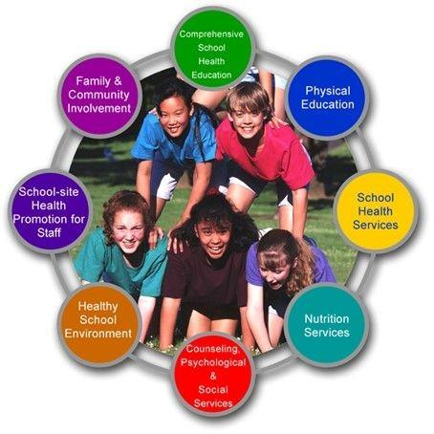

**for SY 2025-2026**

**October 8, 2025 2:00 pm**

**Academy High School**

AGENDA

1. Welcome

What is SHAC-School Health Advisory Council is a group appointed by the school district to serve at the district level. Members of the SHAC come from different areas of the community and from within the school district. SHACs assist the districts in ensuring that local community values are reflected in health education instruction. Additionally, SHACs play an important role in strengthening the connection between health and learning. They can help parents and community stakeholders reinforce the knowledge and skills children need to stay healthy for a lifetime.

1. Recap of last school year 24-25

Review of Backpack Buddies presented by Kayla Andrews

Physicals presented by Nurse Drake and Athletic Trainer

1. Focus Item- Physical Education and Health Services
   1. Mrs. Chaffin presentation on EKG’s
   2. Flu shots provided to our district
   3. Coach Dom presentation on Physicals
   4. Fentanyl Poisoning Awareness Week October 12-18
2. Open Discussion/Question
3. Set date for next meetings

2nd meeting-

3rd meeting-

4th meeting-

1. Recommendations to be brought before the Board of Trustees, Closing Comments, Adjourn Meeting
2. Motion-
3. Second-